To use **offline Nuget Package** from **Given**, follow stetps:

1. Go to your Project in Solution Explorer, right click and select "**Manage NuGet Packages**".

Click **Settings**:

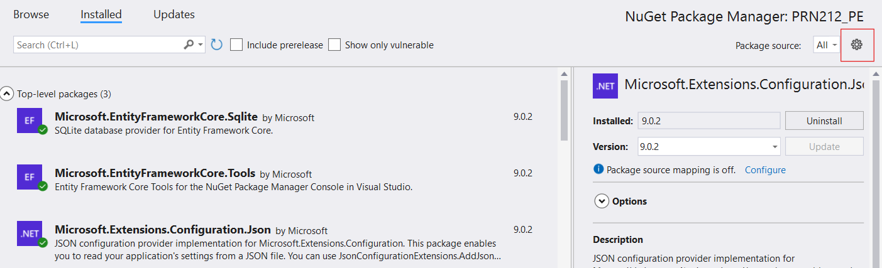

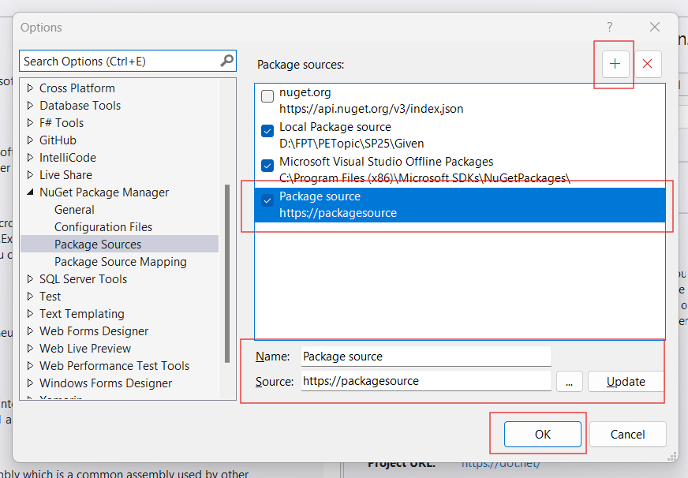

1. **Click +**, Give a **name** and **browse** **folder location**. Click OK. Drop your NuGet package files (from Given folder) into that folder.

To use offline package, un-check **nutget.org** as showed image.

Your new packages will show on **Browse** tab.

